NCBI 鳞翅目转录组信息下载
https://www.ncbi.nlm.nih.gov/sra/?term=Lepidoptera
左侧选择RNA
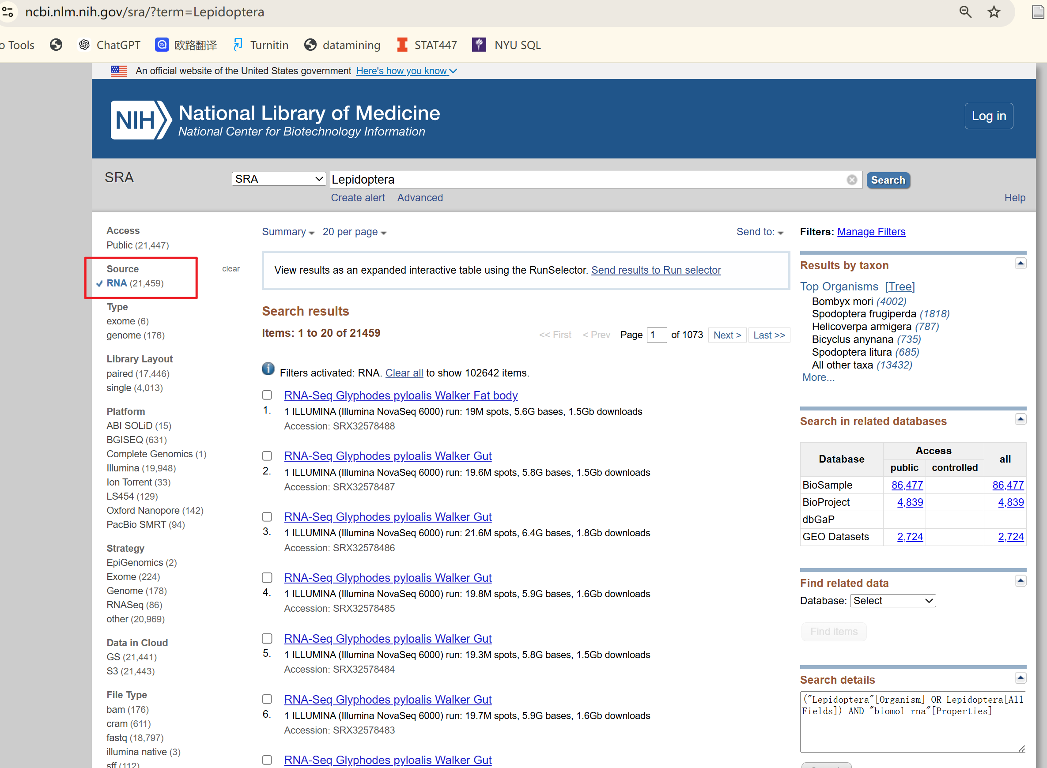

- 下载summary，保存文件需要加下载时间，sra_ncbi_20260320.csv
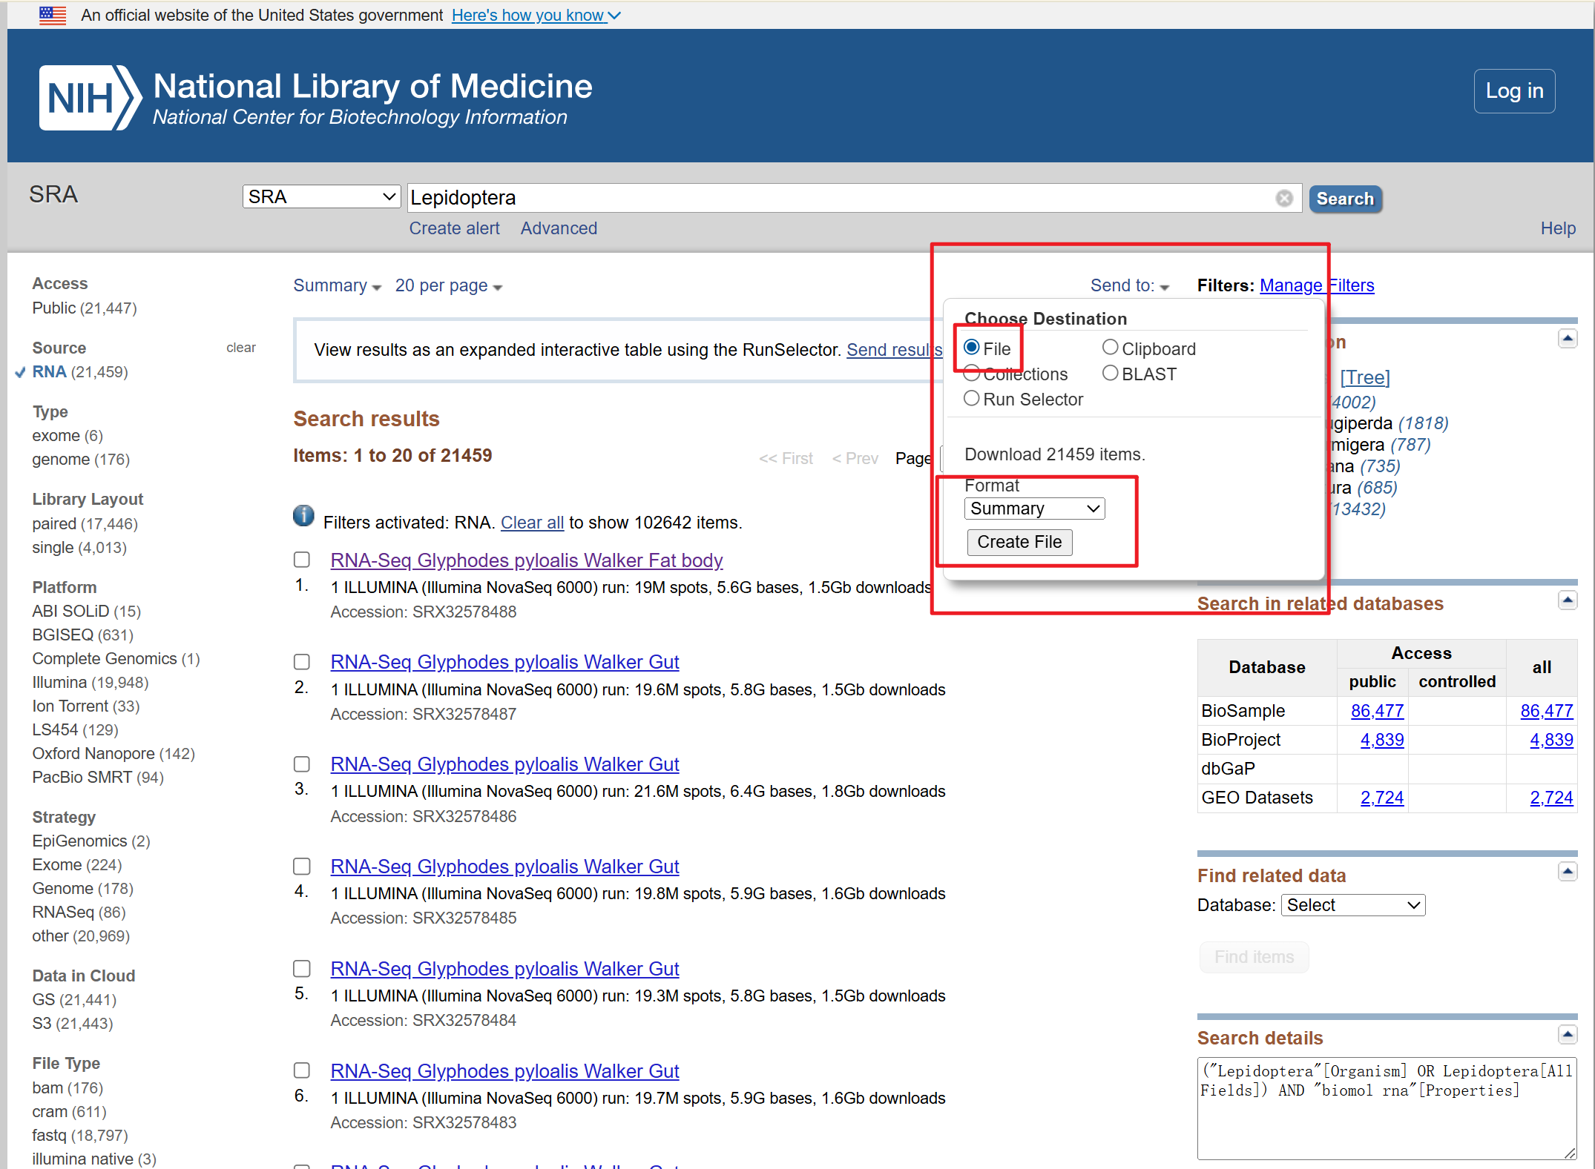
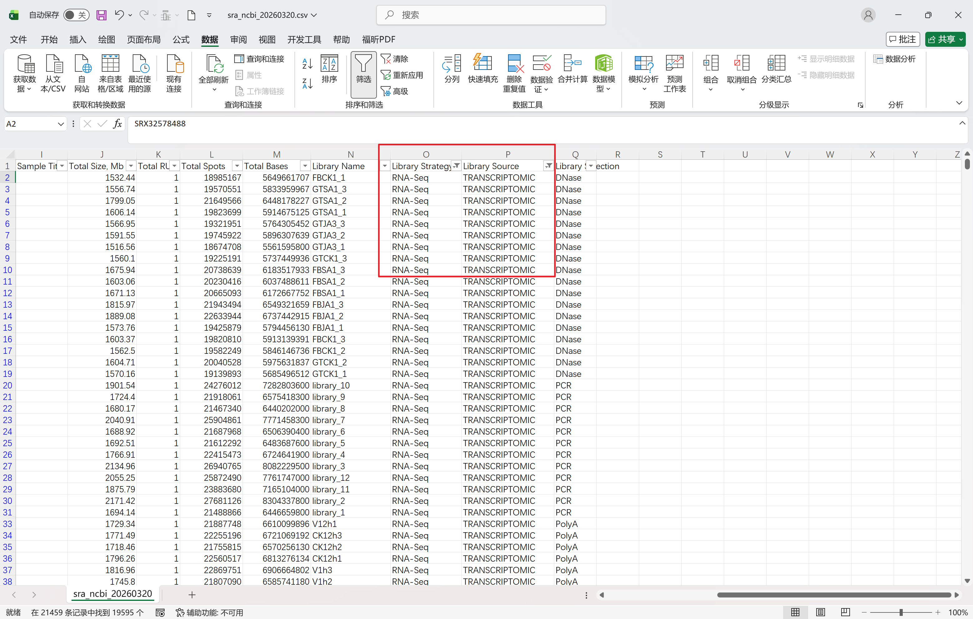

需要保存以下字段：
Experiment Accession
Organism Name
Instrument
Sample Accession
Total Size, Mb
Total Spots
Total Bases
Library Strategy
Library Source
Library Selection

筛选Library Strategy = RNA-Seq , Library Source = TRANSCRIPTOMIC 得到所有符合要求的转录组

- 根据Sample Accession 拼接以下链接SRS28466182
https://www.ncbi.nlm.nih.gov/biosample/SRS28466182
保存Attributes 所有信息，可以直接send to 得到一个json，这个信息有点杂乱，先保存然后再单独处理？
主要需要保存以下个字段Tissue, Sex, Stage ( development stage, lift stage….. ) Collection Date，Geographic location，
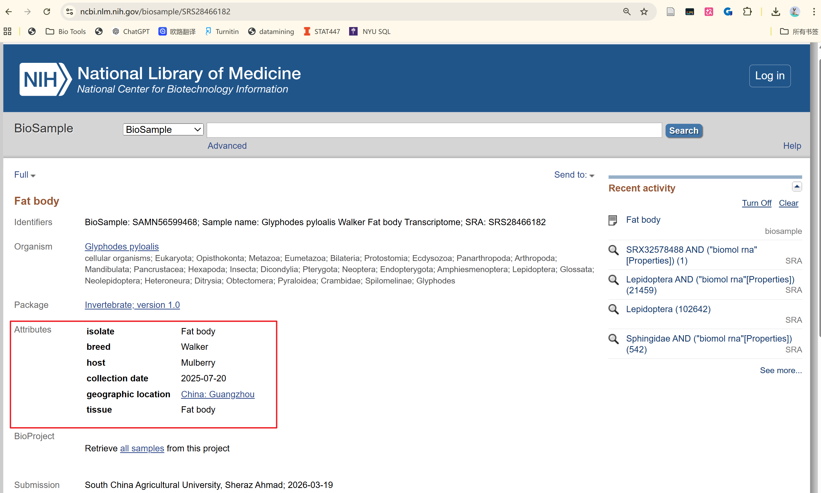
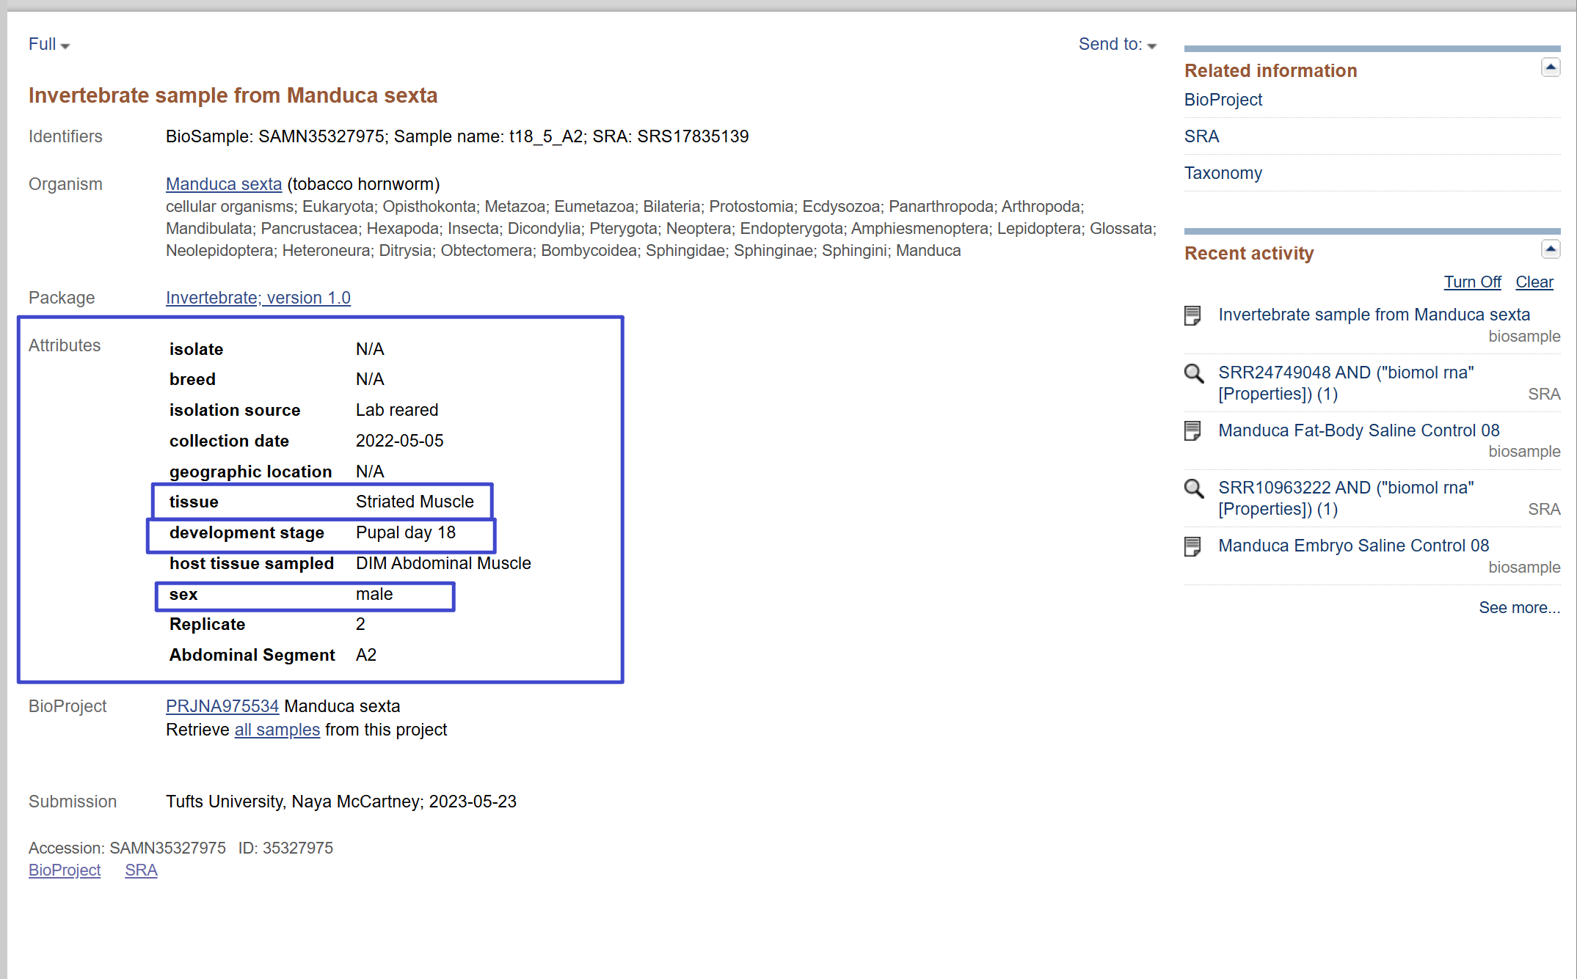

- 根据Experiment Accession 拼接以下链接
https://www.ncbi.nlm.nih.gov/sra/?term=SRX32578488
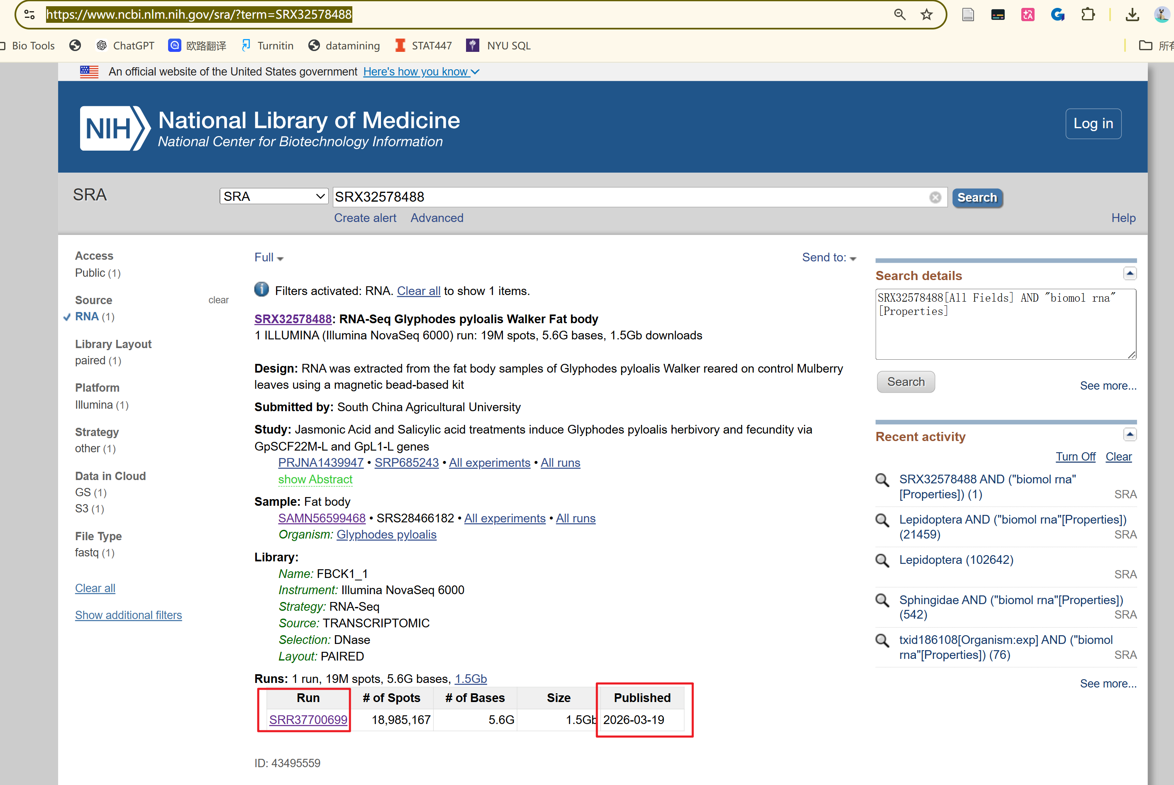

获取这个Run ID拼接得到下载转录组的链接
https://sra-pub-run-odp.s3.amazonaws.com/sra/SRR37700699/SRR37700699
需要保存字段：
Run ID：SRR37700699
Published：
Download Link：https://sra-pub-run-odp.s3.amazonaws.com/sra/SRR37700699/SRR37700699

转录组表字段汇总

Experiment Accession
Organism Name
Instrument
Sample Accession
Total Size, Mb
Total Spots
Total Bases
Library Strategy
Library Source
Library Selection

Tissue
Sex
Stage
Collection Date
Geographic location

Run ID
Published
Download Link

